Loan Management System

Business Requirements Document

# Executive Summary

The Loan Management System will digitize and automate the entire loan process from application to repayment improving efficiency, security and user experience for both borrowers and administrators. This system supports loan applications, approvals, disbursements, repayments and notifications, integrating with third-party APIs for credit scoring and payment gateways.

# Introduction

## 2.1 Purpose

This document outlines the business requirements for the Loan Management System (LMS)which is a tool designed to automate and streamline the lending process. It aims to improve efficiency, security and transparency in managing loans from application through to repayment.

## 2.2 Project Scope

The LMS will handle user registration and management, loan applications, approvals, disbursals, repayments, notifications, reporting and logging activities. It will support borrowers, lenders and administrators and integrate with external services like credit scoring and payment APIs.

**In Scope**

* Admin and borrower pages
* Loan application and approval management
* Repayment processing via payment gateway (zamupay)
* Notifications via sms/emails
* Integration with credit scoring platform
* PDF/Excel exportable reports
* Audit and logging system

**Out of Scope**

* Support for multiple languages (initial version in English only)
* Mobile app (web version only for this phase)

# 3.1 Business Objectives

The business objectives for the loan management system include:

* Reduce manual processing errors and approval delays.
* Enable real-time repayment tracking and reporting.
* Automate and optimize loan processes
* Ensure secure handling of sensitive data
* Ensure timely notifications and alerts via SMS and email.
* Enable real-time tracking of applications, repayments and loan status.

# Key Stakeholders

Borrowers: Submit applications, make repayments and check loan status.

Lenders: View and monitor loans they have funded and manage their lending activities.

Admins: Review applications, approve/reject loans, disburse funds and generate reports.

Third-party Services: Credit scoring, payment gateways and notification systems.

# Business Process

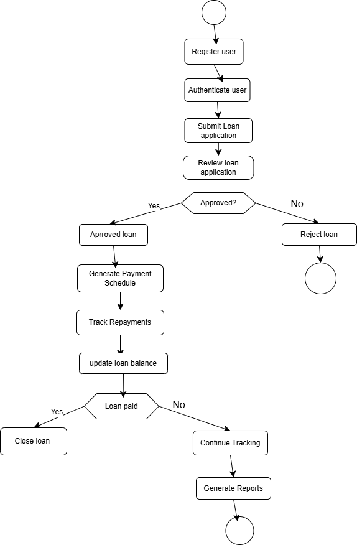

# Requirements

Priority Table

High – Critical functionality of the system

Medium – Important but not critical

Low – future improvements

## 5.1 Functional Requirements

| **ID** | **Requirement** | **Priority** | **Impacted Stakeholders** |
| --- | --- | --- | --- |
| FR-1 | User registration and login for borrowers, lenders and admins | High | All users |
| FR-2 | Submit and track loan applications | High | Borrowers, Admins |
| FR-3 | Fetch credit scores via external API during application | Medium | Borrowers, Admins |
| FR-4 | Approve or reject loan applications with optional comments | High | Admins |
| FR-5 | Disburse approved loans to borrower accounts | High | Admins, Borrowers |
| FR-6 | Record and monitor repayments, generate schedules | High | Borrowers, Admins |
| FR-7 | Allow lenders to view funded loans, monitor repayment status | Medium | Lenders, Admins |
| FR-8 | Enable lenders to fund new loans | Medium | Lenders, Admins |
| FR-9 | Automated notifications for approvals, upcoming payments and overdue | High | Borrowers, Lenders, Admins |
| FR-10 | Generate detailed reports on loans, repayments and user activities | High | Admins, Management |
| FR-11 | Maintain detailed audit logs of all system activities | High | Admins, Compliance Team |
| FR-12 | Integrate with payment gateways for disbursing and collecting repayments | High | Borrowers, Admins |
| FR-13 | Send SMS and email notifications for system events | Medium | Borrowers, Lenders, Admins |

## 5.2 Non-Functional Requirements

| **ID** | **Requirement** |
| --- | --- |
| NFR-1 | Support multiple concurrent users with fast response times |
| NFR-2 | Role-based access control for system security |
| NFR-3 | HTTPS protocol for all communications |
| NFR-4 | Cloud-based infrastructure supporting horizontal and vertical scaling |
| NFR-5 | System availability of 99.9% uptime and backup recovery for the database |
| NFR-6 | Maintain detailed logs for audit and troubleshooting purposes |

# Assumptions and Constraints

Designed for small to medium user base

Stable internet connection required for system use

Integration relies on external API availability and uptime

User interface in English